goAML Web Application
User Manual

[Version 1.1]



Table of Content
1 Overview: 5
2 Pre Requisites: 5
3 Home page menu Before login: 6
3.1 Registration: 6
3.1.1 Register as Organization: 6
3.1.2 Register as Person: 7
3.2 Login: 8
4 Home page menu After login: 10
4.1 Admin menu: 10
4.1.1 Role Management (For Admin User Only) 10
4.1.2 User Management (For Admin User Only) 11
4.1.3 Report Statistics (For Admin User Only) 11
4.1.4 Org Change Request Management (For Admin User Only) 12
4.1.5 User Change Request Management (For Admin User Only) 12
4.2 My goAML Menu 13
4.2.1 Change Password: 13
4.2.2 My User Detail 14
4.2.3 My Org Detail 14
4.3 Message Board Menu 15
4.3.1 Message Board (Search) 15
4.4 Submitted Reports Menu 15
4.4.1 XML Reports: 16
4.4.2 Web Reports: 16
4.5 Drafted Reports Menu 17
4.5.1 Current Report 17
4.5.2 Not Submitted web Reports: 17
4.6 New Reports Menu 18
4.6.1 XML Upload: 18
4.6.2 Web report (Manual): 18
4.6.2.1 Fill Up Report cover 18
4.6.2.2 Add Transaction to Report 20
4.6.2.3 Select Transaction Type, From Type and To Type 20
4.6.2.4 Add Person as source party: 21
4.6.2.5 Add Account as destination party: 22
4.6.2.6 Add Entity Account Details 23
4.6.2.7 Add Account Signatory Details 24

Table of Figures
Fig 2.1: Sample box which can be expanded and collapsed 5
Fig 3.1: Register Menu 6
Fig 3.2: Organization Registration 6
Fig 3.3: Individual user registration 7
Fig 3.4: Reporting person Registration 7
Fig 3.5: Registration attachment and CAPTCHA 8
Fig 3.6: Login page 8
Fig 3.7: Home page after login 8
Fig 3.8: Password Retrieval 9
Fig 3.9: Reset Password Request 9
Fig 4.1: Role Management 10
Fig 4.2: User Management 10
Fig 4.3: Reporting Statistics 11
Fig 4.4: org change request Management 11
Fig 4.5: user change request management 12
Fig 4.6: Reject or Approve a new user 12
Fig 4.7: Change Password Menu 13
Fig 4.8: Change Password 13
Fig 4.9: User Detail 13
Fig 4.10: organization Detail 14
Fig 4.11: Message Board 15
Fig 4.12: Search Message 15
Fig 4.13: Submitted xml Report List 16
Fig 4.14: Submitted web Report List 16
Fig 4.15: not submitted web Report List 17
Fig 4.16: Preview of the report 17
Fig 4.17: Choosing right reporting method 18
Fig 4.18: xml Upload 18
Fig 4.19: Web Report of CTR 19
Fig 4.20: Web Report of STR 19
Fig 4.21: Transaction Button 20
Fig 4.22: Transaction Entry Screen 20
Fig 4.23: Choosing Transaction Type and Party 20
Fig 4.24: Entry Screen After selecting ‘From Type’ or ‘To Type’ 21
Fig 4.25: Person as source party 21
Fig 4.26: Add Phone(s) 22
Fig 4.27: Save Person Information 22
Fig 4.28: Entry Screen After selecting ‘From Type or To Type’ 22
Fig 4.29: Account as Destination Party 23
Fig 4.30: Add Entity 23
Fig 4.31: Entity Information 24
Fig 4.32: Signatory Information 24
Fig 4.33: Person Information as Signatory 25
Fig 4.34: Save Party 25
Fig 4.35: Save Transaction 25
Fig 4.36: Report view with one Transaction added 25
Overview:
This document includes the instructions for how to make a correct web report for transactions and submit to BFIU. In order to make a correct and complete report which meets all the compliances, just go through the document and follow the instructions.
We look forward to receive your valuable feedback through the following email address:
goaml.support@bb.org.bd

Pre Requisites:
- To run the web application the machine has to have internet connection and any browser (Internet Explorer 6.0 or higher is recommended) installed on it.
- To access the application a login is needed and for this the user must have a unique user name and password.
- To have the login credentials an user should be registered through a form which is available in the registration menu.
- The fields in each web form marked with * (asterisk) are mandatory i.e. the form cannot be saved leaving these fields blank.
- Returning to an earlier page after fill in any page, click the Button (Back to ....) at the bottom of the page. It is advised not to click on the ‘page back’ button of the web browser, as this does not always lead to the desired result. In various places there are some boxes that can be expanded or collapsed. When ‘+’ button is clicked besides the label the box, some other mandatory fields can be appeared. For example, while expanding the Location/address box of the Reporting Entity the Address, City, Country fields are mandatory field:

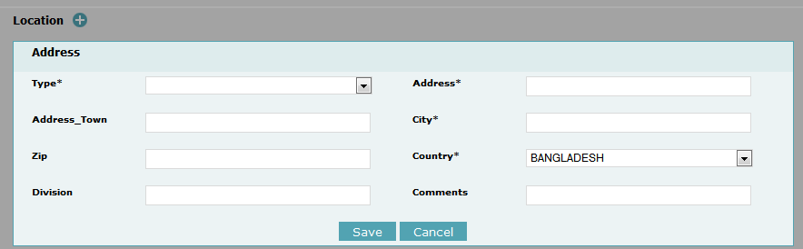
Fig 2.1: Sample box which can be expanded and collapsed

Home page menu Before login:
There are two options or menus on the home page menu bar before login.
One is Register and other is Login.

Registration:
For a new organization/entity registration, click ‘Register as Organization’. This will lead the person to entitle his organization as well as a reporting user.
For a new user registration of an existing entity, click ‘Register as Person’.

Register as Organization:
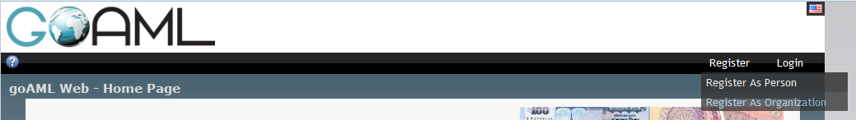
Fig 3.2: Register Menu
For registration, click Register->Register as Organization menu, the following screen will appear:
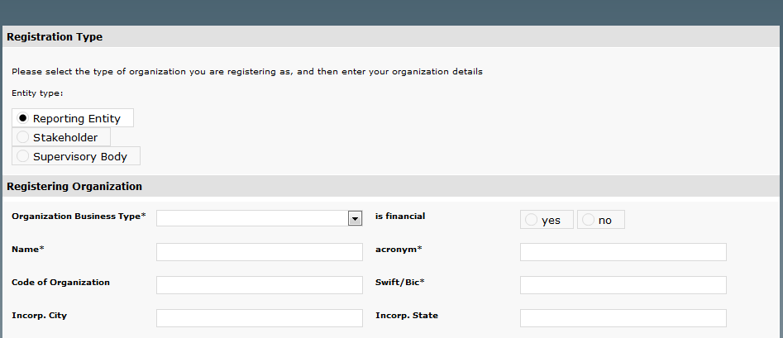
Fig 3.3: Organization Registration
There are three options in Entity/organization type -
- Reporting Entity: The organization which is subject to report to the BFIU. For Example- Bank, Insurance Company etc.
- Stakeholder: The organization which correspond/exchange information with BFIU. For Example: Police, CID, Election Commission, customs, passport office etc
- Supervisory Body: A group of companies or organization controlled by a supervisory body which is subject to report to the BFIU. For Example- Car Dealer Association, Audit Firm, Security Exchange Commission etc
There are four parts for Registration as Reporting Entity-
- Registering Organization (seeks information about Registering Organization. Example: Janata Bank Ltd)
- Registering Person (seeks information about Registering Person. Example: Habibur Rahman)
- Attachments (any necessary document can be add for verification. Example: License document of Organization, id card copy of an employee in case of person registration.)
- A CAPTCHA (which is a program that can generate and grade tests that humans can pass but current computer programs cannot).

Register as Person:
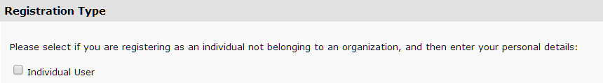
Fig 3.4: Individual user registration
There is another registration type here called ‘Individual user’. Those person who are not from any organization type stated earlier but want to report, can check the box and submit registration form to BFIU.
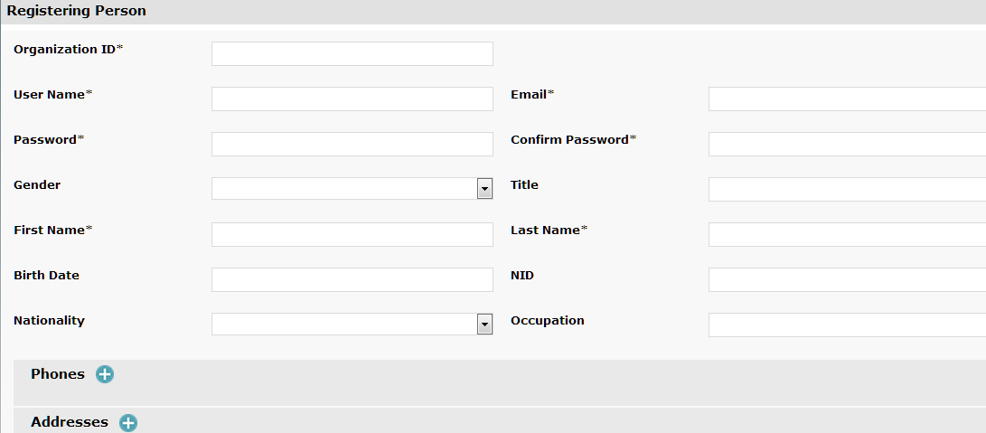
Fig 3.5: Reporting person Registration
- The person who is requesting for a user of an existing organization, he must have to know the organization ID provided by goAML software.
- All the mandatory fields need to filled up here with a sensible username and valid email address.
- Phones and Addresses boxes are also to be filled up.
- Attach any document for verification if needed in the attach area.
- In the CAPTCHA area write the displayed numbers correctly.
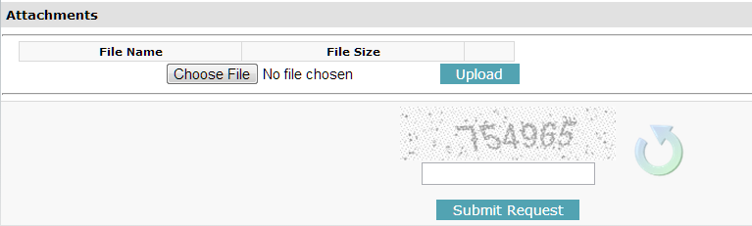
Fig 3.6: Registration attachment and CAPTCHA
After all the boxes filled up click the Submit Request button.
The reporting person will be informed by his provided email that his request is accepted or rejected. If accepted, the person is ready to login to the system.

Login:
Click Login and Login Page will appear as below:
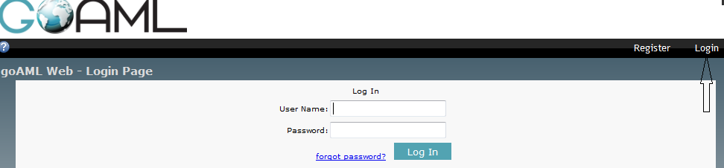
Fig 3.7: Login page
Enter User Name and Password that is given when registration then click Log In button. After successfully Logged In the home page after login will appear as below:

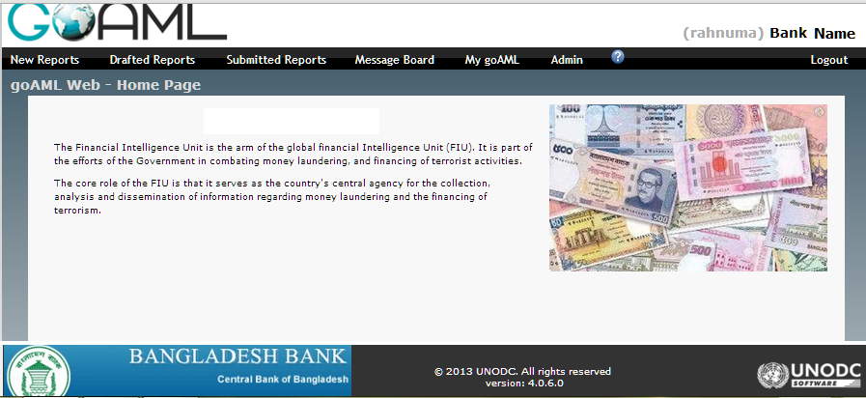
Fig 3.8: Home page after login
In case of retrieval of lost password click forgot password button and follow the instructions.
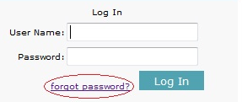
Fig 3.9: Password Retrieval
On the email request box put the email that is previously put when registration.
The system will send a link to that email. By clicking the link from mailbox the user will be able to set new password.
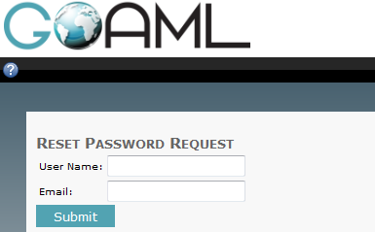
Fig 3.10: Reset Password Request

Home page menu After login:
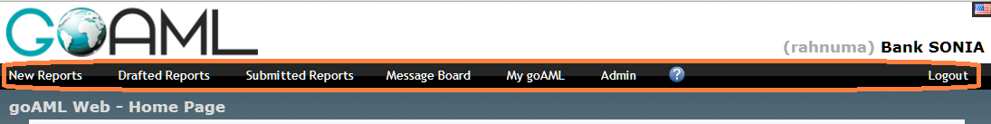
Fig 4.11: Home Page Menu After Login
On the right side corner there shown the user name and entity name and a logout menu below it. The other menus (each one has submenu) are:
- New Reports
- Drafted Reports
- Submitted Reports
- Message Board
- My goAML
- Admin

Logout:
When leaving the web application it is recommended that click logout and end the session.

Admin menu:
It has sub menus related to user and role management of the entity users, change request management and getting reporting feedback.

Role Management (For Admin User Only)
Click 'Admin->Role Management' option and a tabular screen as below will be displayed:
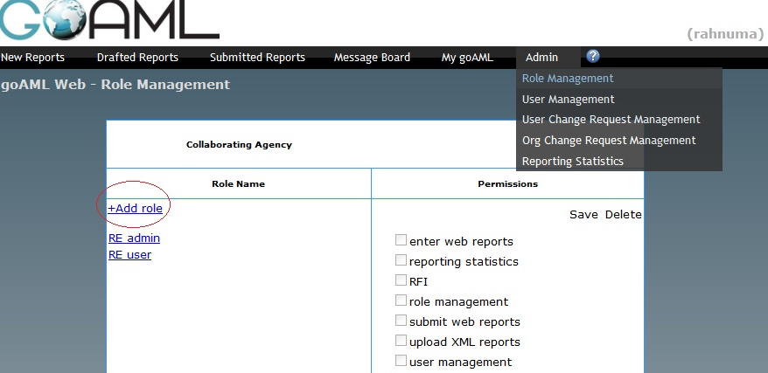
Fig 4.12: Role Management
To create a new role click '+Add role' and write a role name in the given text box and click ‘save’,
To assign permission for a particular role click a 'Role Name' from left side and select appropriate permissions/task from the right side. Save when finished.

User Management (For Admin User Only)
Like role management click 'Admin->User Management' and find the following screen:
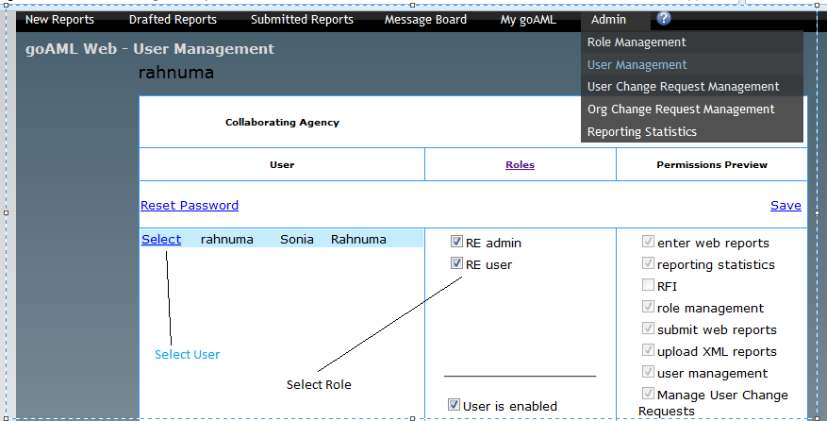
Fig 4.13: User Management
Select a ‘user’ from user list and ‘role/roles’ from roles list and click 'Save'. The permission preview column will show the exact result for the user.
Admin user can reset password for any other user of the entity and also can ‘enable’ or ‘disable’ an user account.

Report Statistics (For Admin User Only)
To get feedback about Reporting to BFIU through goAML click 'Admin->Reporting Statistics' and observe the result like the following screen:
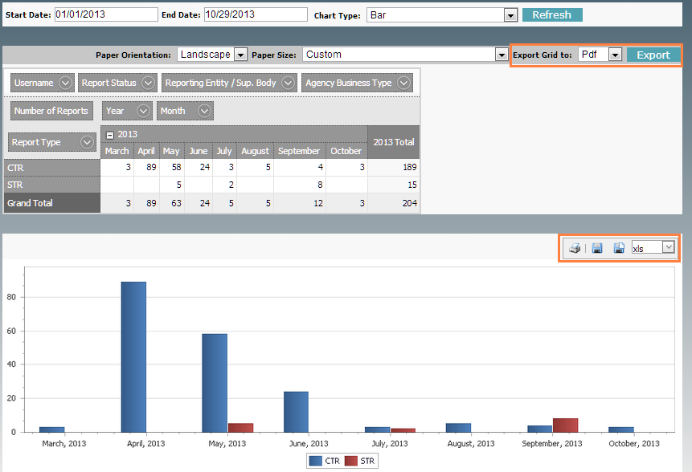
Fig 4.14: Reporting Statistics
The statistics can be regenerate using the pivot tables’ criteria.
The grid can be export to any format and also the chart can be printed or saved to excel or word.

Org Change Request Management (For Admin User Only)
Click 'Admin-> Org Change Request Management’ and find the following screen:
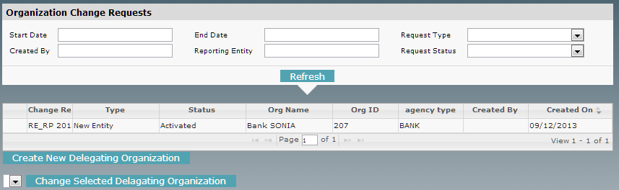
Fig 4.15: org change request Management
This option is for changing supervisory body contents. Adding or changing multiple entities in a body or removing itself from a body dependin upon permissions. All change are listed in the screen in details.

User Change Request Management (For Admin User Only)
Like org change, click 'Admin-> User Change Request Management’ and reach the following screen:
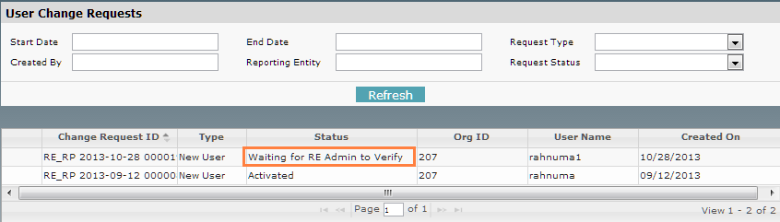
Fig 4.16: user change request management
This option is for user request management. When a new user request comes it waits for verification and approval.
Verification and approval will be done by reporting entity’s admin user and finalize will be done by BFIU. As previous, all the history are listed with date.
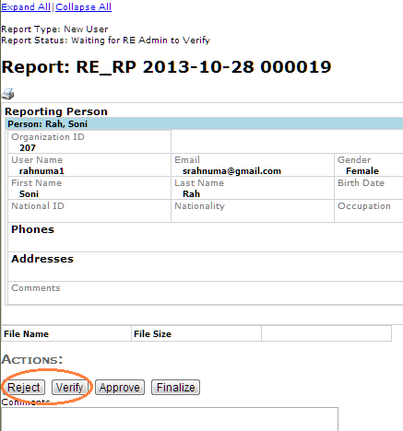
Fig 4.17: Reject or Approve a new user

My goAML Menu

Change Password:
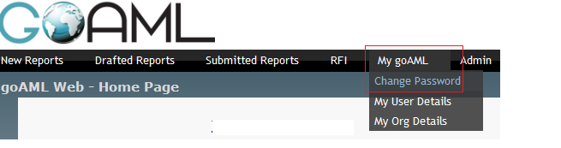
Fig 4.18: Change Password Menu
To change current user password click 'My goAML->Change Password' Menu and reach the following screen:
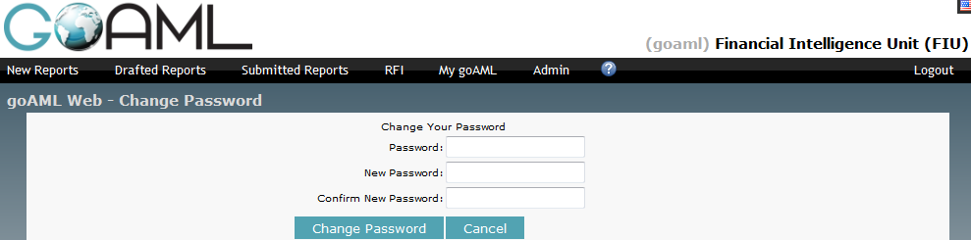
Fig 4.19: Change Password
Enter Current Password, New Password, Confirm New Password and click 'Change Password' Button to change current password.

My User Detail
Click 'My goAML->My User Details' menu to see the detail information of user.
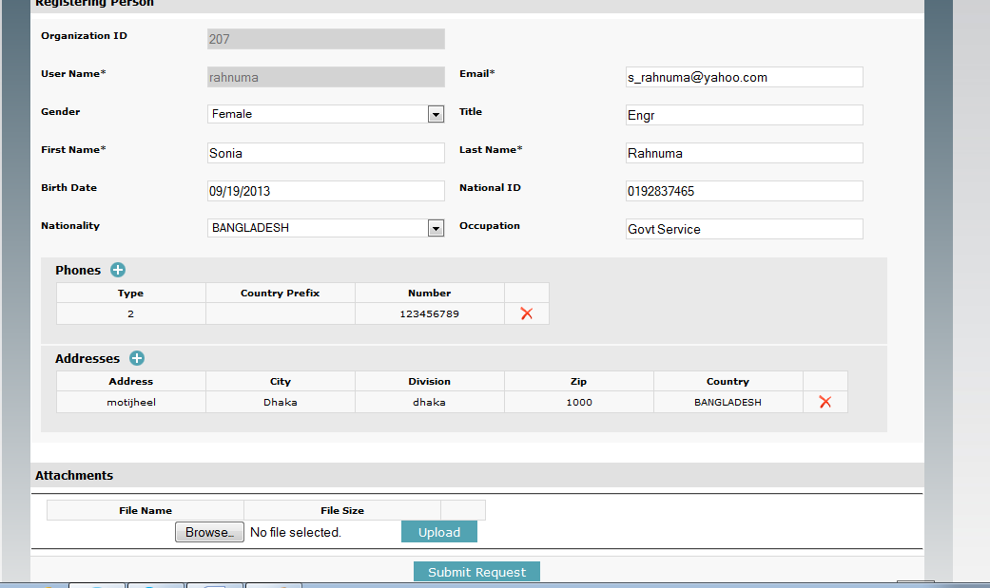
Fig 4.20: User Detail
All the details about the current user can be change from this screen except org ID and username. Admin users can change email others cannot.
This change request will be verify and set by entity admin user.

My Org Detail
Click 'My goAML->My Org Details' menu to see the detail information of an entity.
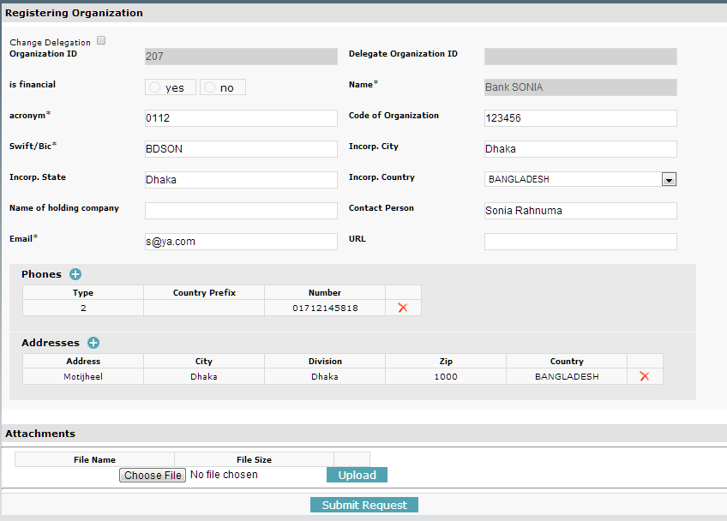
Fig 4.21: organization Detail
Like User Details All about the current entity can be change from this screen except org ID, Delegate Org ID and org name.
This change request will be verify and set by entity admin user.

Message Board Menu
Click 'Message Board' menu to view the incoming messages and send message to BFIU. Message Board consists different folders.
The web report those fully accepted by BFIU are stored in 'Report Fully Accepted' Folder. Similarly Partially Accepted and Rejected web Reports are stored in 'Report Partially Accepted' Folder and ‘Report Rejected’ Folder respectively.
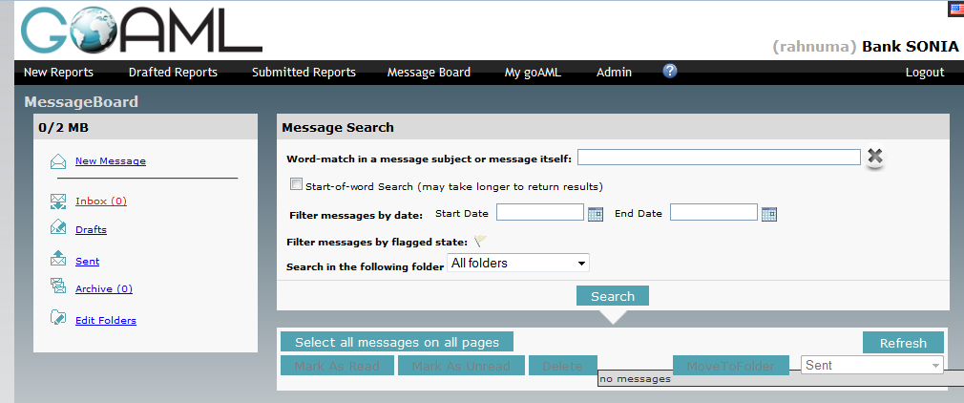
Fig 4.22: Message Board

Message Board (Search)
There is an option to search messages in all folders or in selected folders. Type a word in the text box and set option to filter with 'Start Date and End Date' then click on ‘Search’ button to start searching:
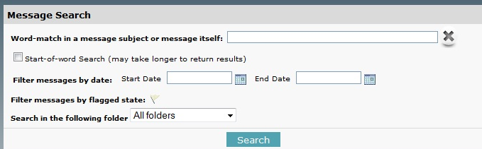
Fig 4.23: Search Message

Submitted Reports Menu
- There are options to filter submitted reports list based on some criteria.
- Status can be Uploaded, Transferred from web, Failed Validation, Rejected, Processed.
- Uploaded means it is successfully uploaded but not yet validated.
- Failed Validation means submitted web report is ‘Failed’ for Validation issue.
- Clicking on Failed Validation would show the error message with a button ‘Revert’. Once revert is clicked, the status becomes ‘Reverted’ and error message disappears. So it is advised not to click the button ‘Revert’.
- Transferred from web means the report is validated and went to db server for processing.
- Rejected means BFIU rejected the web report and Processed means BFIU accepted the Web Report.
- Click the icon (oval indicated) to view or print the Summary of the report as below.
- Click the X button beside that to remove the report from web.

XML Reports:
Click 'Submitted Reports->xml Reports' to see status of submitted reports that are collectively generated in a XML file and uploaded using web xml upload option.
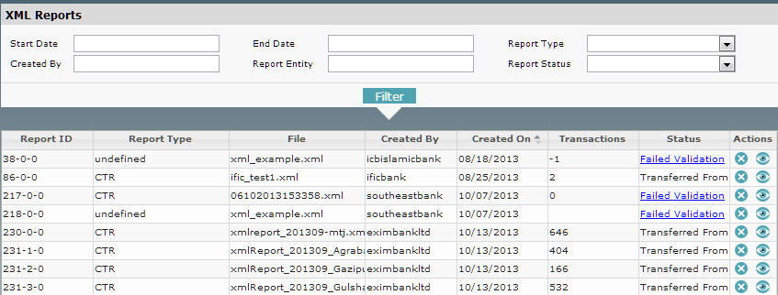
Fig 4.24: Submitted xml Report List

Web Reports:
Click 'Submitted Reports->web Reports' to see status of submitted reports that are created using the web application.
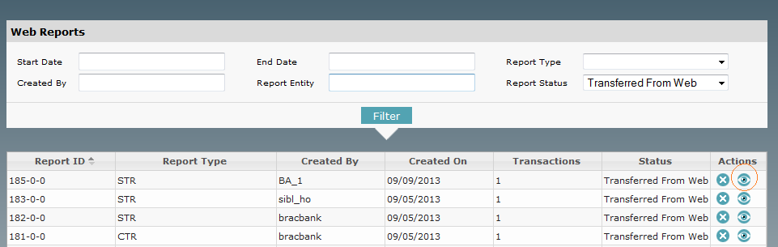
Fig 4.25: Submitted web Report List

Drafted Reports Menu

Current Report
The latest incomplete report is stored and can obtain as it was by clicking this option. The option is user dependent. One user cannot see other user’s current report.

Not Submitted web Reports:
Click this menu to get the drafted or not submitted reports that are created using the web application. Admin user can view all the reports but normal user can view individual reports only.
- There are options to filter submitted reports list based on some criteria.
- Status is Not Submitted.
- Click the icon (oval eye) to view or print the Summary of the report as below.
- Click the X button beside that to remove the report from web.
- Click the edit (pen) icon before that to modify or submit a drafted report.
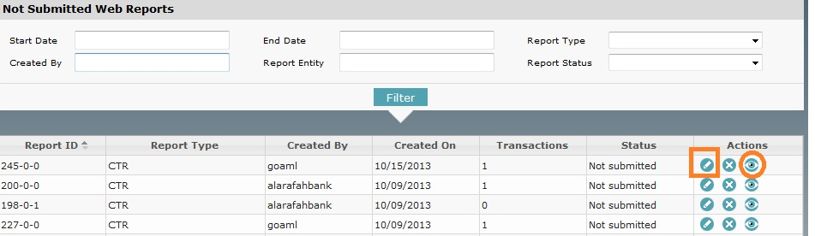
Fig 4.26: not submitted web Report List
For Print this preview page click ‘Print’ Button (is marked with Oval in above the screen).
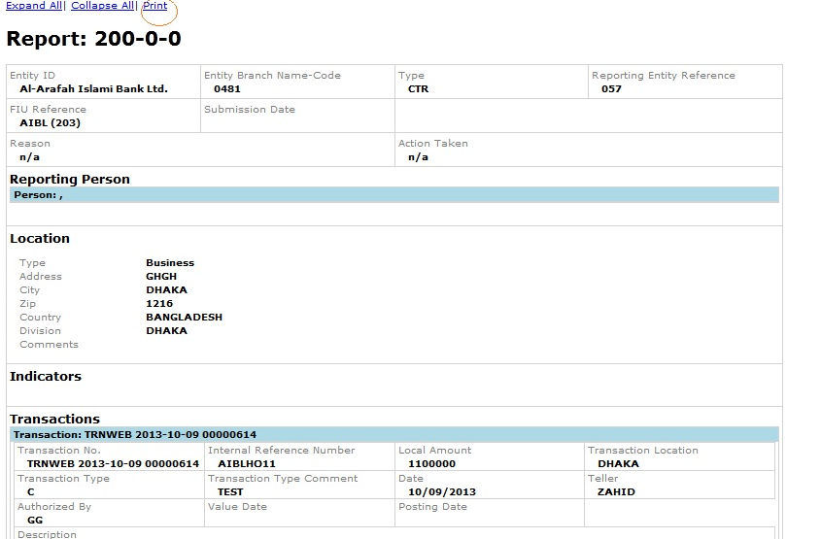
Fig 4.27: Preview of the report

New Reports Menu

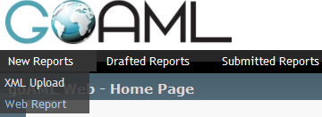
Fig 4.28: Choosing right reporting method
Choose the preferred Report Submission method by clicking New Reports Menu.
There are two ways to submit report.
- XML Upload
- Web Report (Manual)

XML Upload:
- Generate XML file using the skeleton schema provided by BFIU and submit it using this option.
- Click Browse Button. Choose the appropriate xml file from own location.
- Click Upload button to upload xml file in BFIU goAML Server.

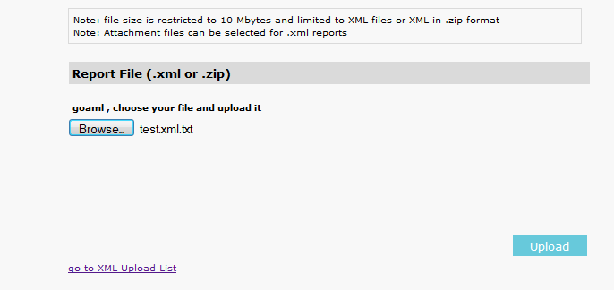
Fig 4.29: xml Upload

Web report (Manual):

Fill Up Report cover
Click New Reports->Web Report to prepare the report using web form. The following screen will appear:
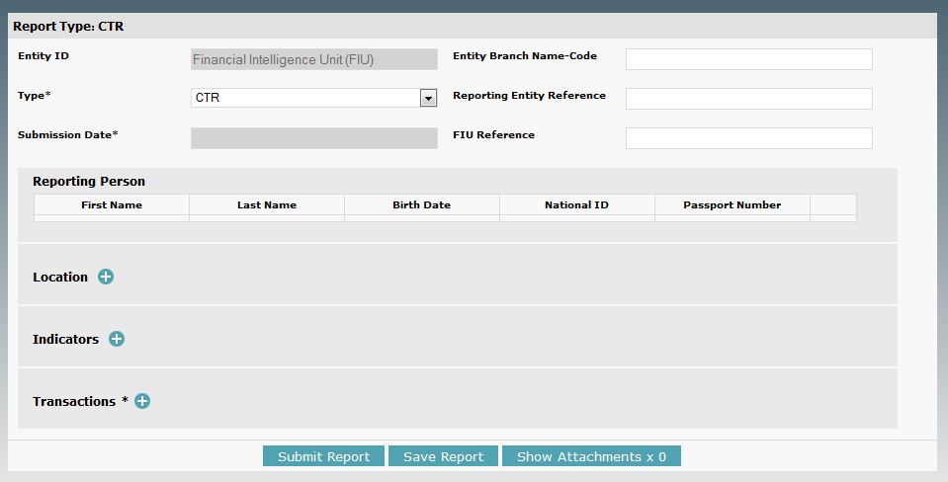
Fig 4.30: Web Report of CTR

Fill up all data in the screen. The field marked with * is mandatory. Choose appropriate Report Code. If report code is CTR then follow above screen. For STR this screen is different as below. In case of STR, Reason for suspicion, Action, Report Indicators are three extra fields from CTR. After fill up all required information click Transaction button to entry transaction information.

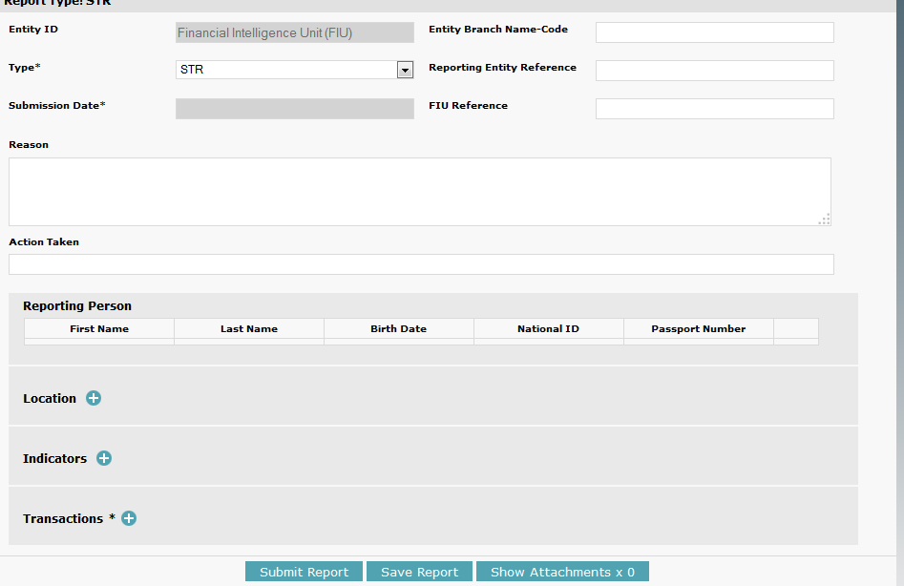
Fig 4.31: Web Report of STR

Add Transaction to Report
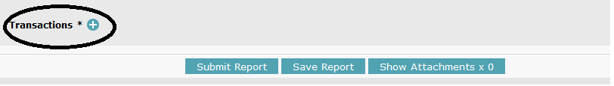
Fig 4.32: Transaction Button
After Clicking transaction box see the following screen
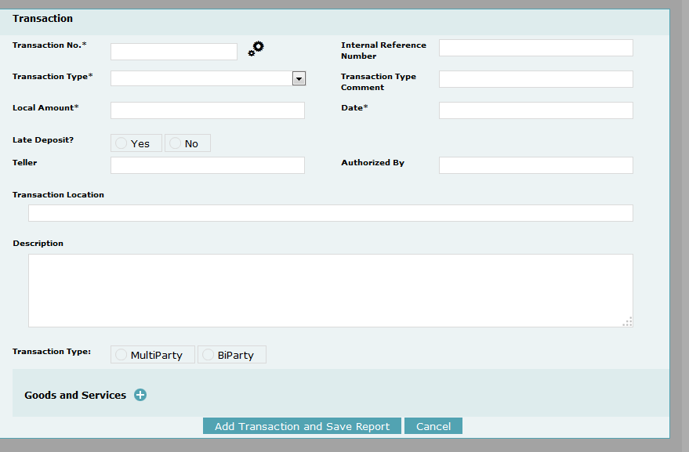
Fig 4.33: Transaction Entry Screen
Here Internal Reference Number is ‘transaction tracking number’ of the reporting organization. ‘Transaction No’ is same as Internal Reference Number. Select appropriate ‘Transaction Type’ either Bi-party or Multi Party. If Transaction occur between person-account or account-account or account-person then click Bi-party.

Select Transaction Type, From Type and To Type
Selecting Transaction Type to bi-party, select ‘From Type’ (Source Party) and ‘To Type’ (Destination Party) as below screen:
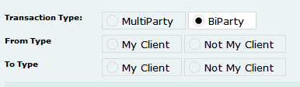
Fig 4.34: Choosing Transaction Type and Party
Bi-directional transactions are composed of a source and destination. The source and destination may be either a person, an account or an entity. For account deposits, the source is a person and the destination is an account. For account withdrawals, the source person is account and the destination is person. For account transfers, we will have account to account transactions. In this case source and destination is account. If account or Person is the client of organization then select ‘My Client’ radio button, otherwise select ‘Not My Client’. Considering ‘From Type’ and “My Client” Radio button and get following Entry Screen:
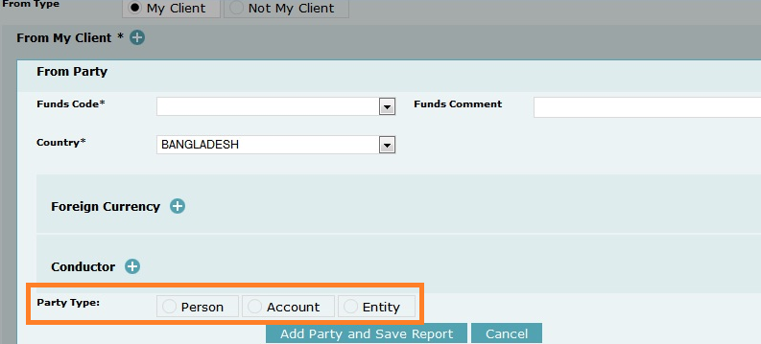
Fig 4.35: Entry Screen After selecting ‘From Type’ or ‘To Type’
Select Appropriate Party Type. Considering ‘Deposit Transaction’ in this manual So source party is person and destination party is account.

Add Person as source party:
For ‘My Client’ option at least one Phone, Address and Identification is mandatory.
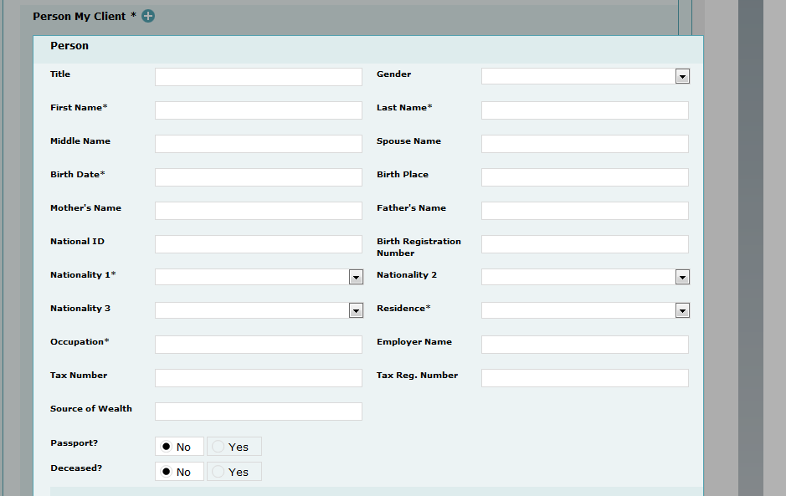
Fig 4.36: Person as source party
Click ‘+’ button beside Phones to entry phone information of Person and see the following screen.
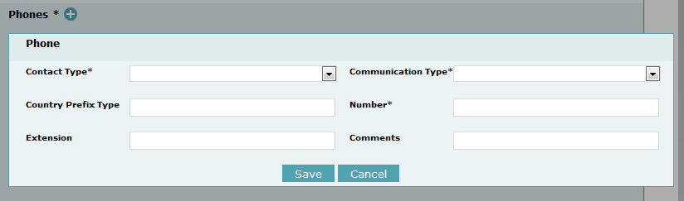
Fig 4.37: Add Phone(s)
Fill up all necessary field and click ‘Save’ Button.
In similar way, fill up at least one Address and one identification. After filling all data click ‘Save’ button to save Person information as source party.
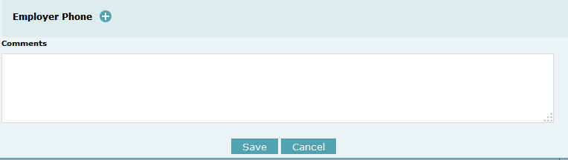
Fig 4.38: Save Person Information

Add Account as destination party:
Considering ‘To Type’ and “My Client” Radio button and get following Entry Screen:
Fig 4.39: Entry Screen After selecting ‘From Type or To Type’

Like source party, three option to choose ‘Person or Account or Entity’ as destination party. The following screen shows when Account is chosen as destination party:
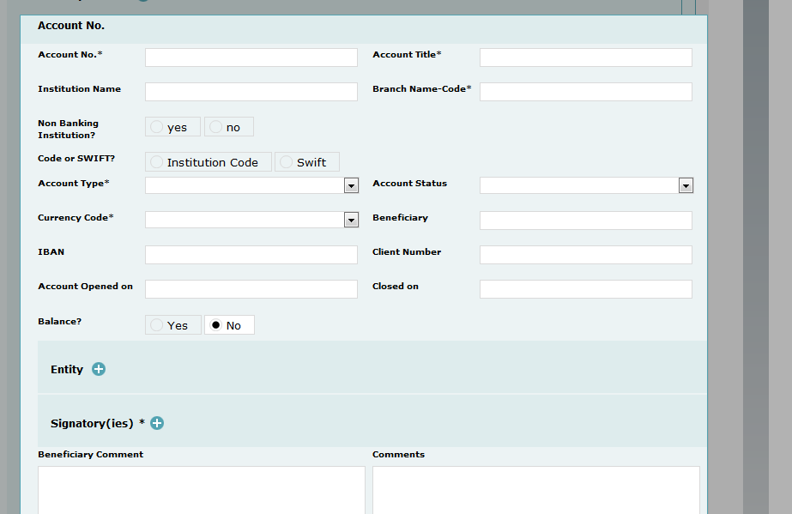
Fig 4.40: Account as Destination Party

Add Entity Account Details
If this account is company account Click ‘+’ Button beside and fill up required fields.
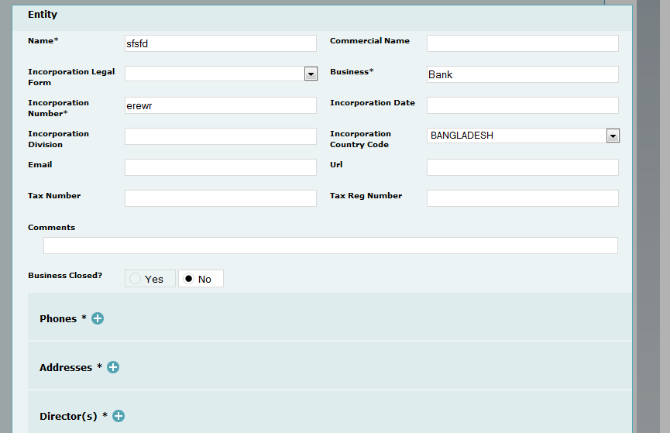
Fig 4.41: Entity Information
At least one company phone, Address and Director is needed to fill up. Fill up all required field and Click ‘Save’ button to save Account information as destination party .After that get option to add account signatory/s as following screen.

Add Account Signatory Details

Click "+" button to add account signatory.
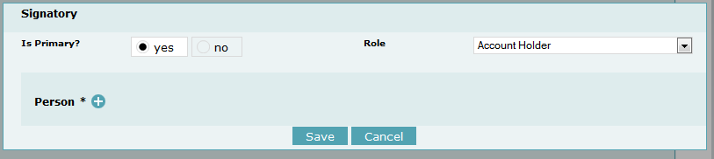
Fig 4.42: Signatory Information
If the signatory is primary account holder then click ‘yes’ in Is primary option and select appropriate role of that signatory. The click ‘+’ button besides Person to add detail information of signatory.
Fig 4.43: Person Information as Signatory
Fill up all required field and click ‘Save’ to save signatory information.
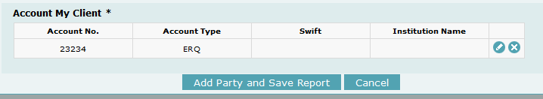
Fig 4.44: Save Party
At last click ‘Add Party and Save Report’ to add ‘Account’ information as destination account.

Fig 4.45: Save Transaction
After saving party information see the screen as above. Click ‘Add Transaction and Save Report’ to save transaction information.
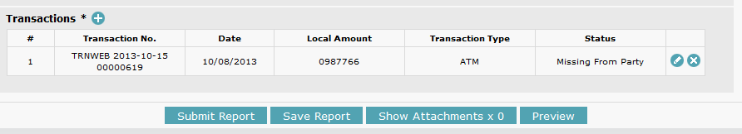
Fig 4.46: Report view with one Transaction added
If required to add more transaction then click ‘+’ button besides Transaction. For submit ion the report click ‘Submit Report’ button. Have option to see preview of the report before submitting by clicking ‘Preview’ button.

